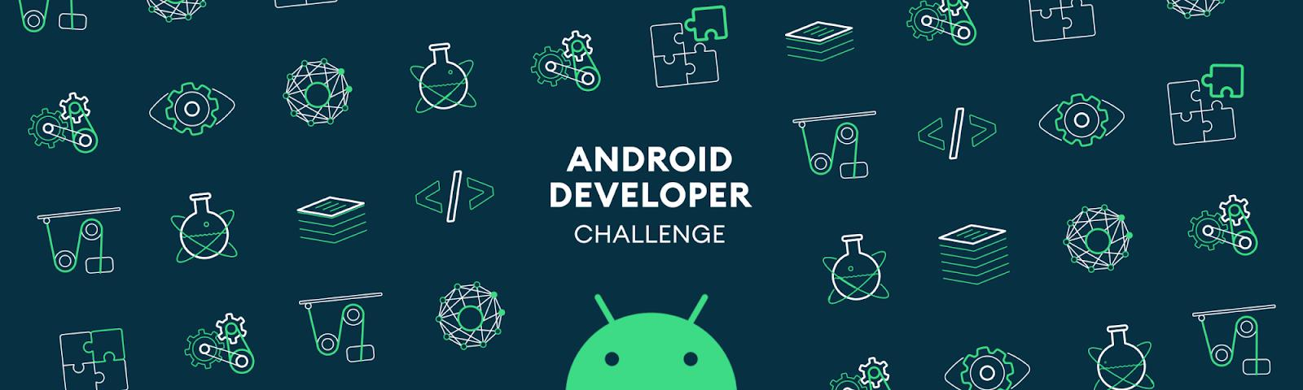

**Tell us what your idea is.**



*This Idea will provide a digital folder to all the user’s important documents into e-format.*

*As in most of the rural areas since people are not aware of the digital/e-format of the documents, they keep the original hard copy of the documents extremely carefully .*

*When the user issues or enrol for a document, the user will have to link email ID using the app so that the original e-format copy of the document could be saved in the google drive cloud storage(which is free upto 15GB)and thus the security of the google will also be provided after the documents are uploaded to the google drive.*

*It will be a convenient and economically free way to save the document online.*

**Tell us how you plan on bringing it to life.**



* Google’s drive shall be used to save the documents online.
* Google’s security shall be provided for the online storage.
* Gmail ID will be used to create online profile/account .
* The idea shall be considered under DIGITAL INDIA SCHEME.

**Tell us about you.**



* My name is Dheeraj Bhardwaj.
* Age - 17
* I have passed class 12th from Kendriya Vidyalaya Andrews Ganj,New Delhi ,in 2019.
* Have studied programming in C++ till class 12th .
* Currently I am doing B TECH from ELECTRONICS AND COMMUNICATION branch from REWA ENGINNERING COLLEGE, REWA MADHYA PRADESH.